**Leader Overview**

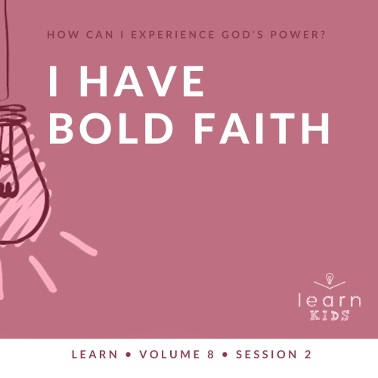

**Volume Overview**

**How can I experience God’s power?**

*When we think of power, we might think of physical strength or mental toughness. While God surely wants us to experience physical health and clarity of mind, He desires that we experience His supernatural power too.*

*In the Bible, it’s clear that our God—revealed through the Father, the Son and the Holy Spirit—is powerful. He spoke the world into existence and sustains the universe by the power of His Word (*[*Hebrews 1:3*](https://ref.ly/logosref/Bible.Heb1.3)*). God displayed His power in many ways in the Old Testament for His people. In the New Testament, Jesus’ life and works revealed His power over sickness, spiritual forces, and even the grave. After Jesus’ resurrection, God sent the Holy Spirit so we could have the power to do kingdom work today (*[*Acts 1:8*](https://ref.ly/logosref/Bible.Ac1.8)*). Clearly, God is powerful! But how do you and I experience His power? That’s the question we’ll explore in this volume.*

**Session Overview**

**I Have Bold Faith**

*We must believe in God with a bold faith. Over and over in Scripture we can see that when God’s people believed for the impossible, He heard their requests and responded with action. Elisha believed for a doubled spiritual inheritance from his predecessor, Elijah. God granted that based on both his and Elijah’s bold faith. Kids will learn that they can believe God will do greater things in their life, just as He did for the prophet Elisha.*

**Bible Lesson**

Elisha’s Double Portion

[2 Kings 2:6–15](https://ref.ly/logosref/Bible.2Ki2.6-15)

**Faith Fact**

I believe God can do great things.

**Faith Verse**

[John 14:12](https://ref.ly/logosref/Bible.Jn14.12) (NLT)

“I tell you the truth, anyone who believes in me will do the same works I have done.”

**Preparing for the Session**

**Leader Preparation Time: 20–25 Minutes**

|  |
| --- |
| ***You Will Need***  ***Large Group***   * *Bible* * *Worship songs (Song suggestions: “Way Maker” by Hillsong Worship; “Miracles” by Vertical Worship; “Nothing Is Impossible” by Planetshakers; “Love Won’t Let Me Down” by Hillsong Young & Free)* * *For groups not using a phone or tablet only, add:*   *• Projector or TV*  *• Laptop*  *•* ***Faith Fact Slide***  *•* ***Faith Verse Video*** *or* ***Slide***  *•* ***Bible Lesson Video***  *•* ***Teaching Point Slides 1–3***   * *Bowl* * *Popcorn* * *TV remote*   ***Small Group***   * ***Small Group Group Connection Page****, one per group* * *Candy or small prize, one piece per kid* * *Scissors* * *Plastic cups, one per group* * *Bibles for kids in your group to share* * *Small prize* * ***Small Group Activity Page****, one per kid* * ***Small Group Activity Page Answer Page*** * *Pencils, one per kid*   *To access session content and videos from a computer, visit:* [*BibleEngagementProject.com/downloads*](https://bibleengagementproject.com/downloads) |
| ***Getting Ready***  ***Large Group***   * *Download videos and slides if needed.* * *Select worship song(s) and have them ready to play.* * *Read the Bible Lesson Scripture to prepare for Teaching Time.* * *Fill the bowl with popcorn.*   ***Small Group***   * *Print copies of the* ***Small Group Group Connection Page****, one per group.* * *Cut each page into slips and place the slips in a cup, one set per group.* * *Print copies of the* ***Small Group Activity Page****, one per kid and a* ***Small Group Activity Page Answer Page*** *for you.*   *First time leading* Learn *for Kids? Check out the* [*Facilitator Guide*](https://0b769b0ed3569ef9d18b-f88d8272f61086866d50d048b43ef630.ssl.cf2.rackcdn.com/sites/biblengagementproject/Listen_Facilitator_Guide.pdf)*.* |

**Large Group**

**30 Minutes**

*See what’s needed at the beginning of the session.*

**Introduction**

I’m so glad you’re here! Last time, we were learning all about God’s power. How powerful do you think God is? *(Allow responses.)* He is all-powerful. No one compares to God. Do you believe that? *(Group response)* I mean, do you really believe it? *(Group response)*

How do you think we can show God we believe He is powerful? *(Allow responses.)* Awesome answers! We’re going to talk about a prophet who believed God could do something powerful in his life. God saw the prophet’s bold faith and did great things for and through him.

**Faith Fact**

That reminds me of today’s Faith Fact. Our Faith Fact is **I believe God can do great things.**

• *Show the* ***Faith Fact Slide.***



Let’s say that together a few times. Each time we say the word *great*, jump as high as you can. **I believe God can do great things.**

• *Lead the kids in saying the Faith Fact a few times.*

That was some terrific jumping! Now let’s discover more about the great things God can do.

**Game**

**Which One Is Better?**

There’s no doubt God is greater than anyone or anything in this world. He’s the best! But we can debate about other things—like food! Everyone has different likes and dislikes when it comes to what they eat.

In today’s game, you’ll decide which food is greater. It might be a hard choice because you may like both foods I mention. But you should choose the one you think is better. I’ll name two foods. If you like the first one more, you’ll put your hands up high in the air. If you like the second food more, you’ll bend down and touch the floor. Let’s find out which one you think is better!

• *Read each pair and let kids choose. Do a quick count for each round and declare the “greater” food before moving on.*

Which one is better?

• Chocolate chip cookies or chocolate cake?

• Strawberry milk or chocolate milk?

• Soda pop or juice?

• Gum or lollipops?

• Pizza or macaroni and cheese?

• Hamburgers or hot dogs?

• Smoothies or snow cones?

• Grilled cheese or PB&J?

• Spaghetti or tacos?

• Waffles or pancakes?

• *Optional: Let kids suggest additional pairs if you have time.*

We didn’t all agree on which foods were better, but we can all agree that God is the best. If you agree, shout, “Amen!” *(Group response)*

**Worship**

One of the ways we tell God we know He’s the greatest is by worshipping Him and praising His name. Let’s do that right now by singing.

• *Lead the kids in singing one or two praise songs. See suggestions at the beginning of the session.*

**Bible Lesson**

What an amazing and powerful time worshipping God with all of you! Last time, we talked about Elijah, God’s prophet who told the people what God wanted him to say. What amazing and unusual way did God deliver food to Elijah? *(Allow responses.)* God sent ravens with food for Elijah. That definitely seems impossible, but nothing is impossible for our powerful God. He can do great things.

Today we’ll look at Elijah’s last day of ministry. It was no ordinary day! Elijah’s exit from the world was very powerful, and God was going to do even more great things through the prophet who came after him. Let’s pray and ask God to get us ready to discover new things in His Word today.

**Prayer**

|  |
| --- |
| *Dear God, thank You for Your Word and the way it shows us Your power and the great things You can do. Help us believe You will do great things in our own life. Amen.* |

**Video Intro**

Before we dive into the Bible story, let’s take a look at this video.

• *Play* ***Bible Lesson Video****.*

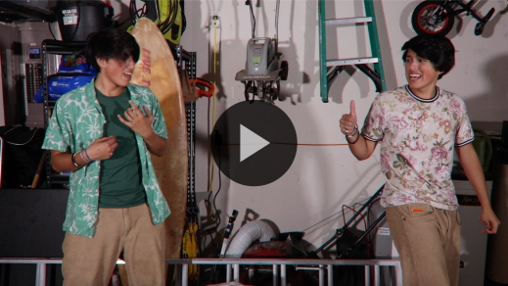

**Bible Story**

**Elisha’s Double Share**

That video was a cool way to set up our Bible story today! Elijah had done many incredible and miraculous things through God’s power. He had prophesied awesome and even terrible things. But it was time for his ministry to end. God was about to take Elijah to heaven.

Elisha had been following Elijah and learning from him. Elisha was ready to become a prophet like Elijah. In fact, Elisha asked for something really bold. He believed God could do it! Grab your Bible or open the Bible app on your device and go to [2 Kings 2:6–15](https://ref.ly/logosref/Bible.2Ki2.6-15) to read along. Let’s find out how God responded to Elisha’s bold request.

• *Read the Bible story aloud to the group.*

• *In order to keep Large Group time moving along, we don’t recommend having the kids read.*

• *Optional: Remind the kids to mark this place with their Bible Bookmark, so they can read it on their own at home.*

**Teaching Time**

|  |
| --- |
| ***You Will Need***   * *Bowl* * *Popcorn* * *TV remote*   ***Getting Ready***   * *Fill the bowl with popcorn.* |

Bold faith means we believe something and then do something about it. Do you have bold faith? *(Group response)* Elisha’s faith was definitely bold when he asked God to make him a powerful prophet like Elijah.

God had done miracles through Elijah. Earlier Elijah had gathered the prophets of a false god, Baal, to prove whose God was greater. Elijah asked God to send fire from heaven to show His power, and God did it! Then Elijah asked God to send rain, and God did that too! Elisha knew God had done miracles through Elijah, and he believed God could do even greater things. That’s what our Faith Fact says: **I believe God can do great things**. Say that with me and jump up out of your seat when we say the word *great*. **I believe God can do great things**. Let’s find out three amazing truths about having bold faith.

**1. Faith is believing for something we can’t see.**

• *Show the* ***Teaching Point 1 Slide.***

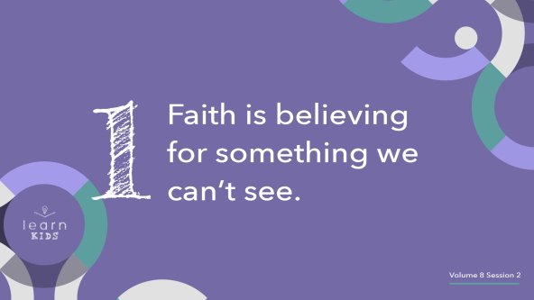

Faith is believing God will do something even when it doesn’t seem possible. We can’t see how God will do it, but we choose to believe He will. The Bible says in [Hebrews 11:1](https://ref.ly/logosref/Bible.Heb11.1) that faith is literally the evidence for what we cannot see.

Let’s talk about a couple of things we believe in but can’t see. Think about the wind. Can you see the wind? *(Group response)* How do you know the wind is real if you can’t see it? *(Allow responses.)* We know the wind exists because we can see the effect it has on trees. We can feel the wind when it blows against our skin.

What about helium? We use helium to fill balloons so they can float in the air. We can’t see helium, but we know it’s real because we can see the effect it has on a balloon. What are some other things that most people believe in, but they can’t see? *(Allow responses.)*

Those are fantastic answers. Believing in God is similar to the examples you shared. We may not be able to see God, but we can read His Word every day. We can see the effects He has on our life and the lives of others. That’s why it’s so important to share stories of what God is doing in our life. Our testimonies show others that God really does exist.

**2. We believe God can do the impossible.**

• *Show the* ***Teaching Point 2 Slide.***

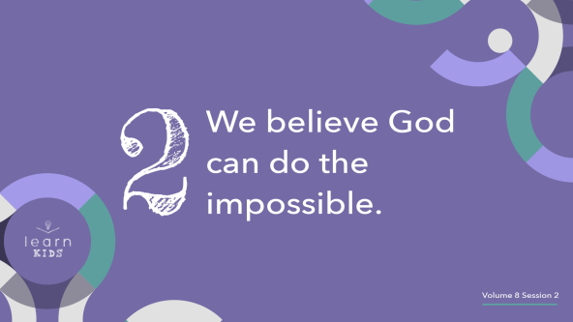

Can any of you do a cool trick that most people can’t do? *(Group response)* I’m going to choose a few of you to come up and show us your trick.

• *Choose a few kids and allow them to show off their cool tricks in front of everyone.*

Wow! Those were some awesome tricks that not everyone can do. But they aren’t impossible. Why do I say that? Because you did them! God’s miraculous power goes so far beyond the amazing things you and I can do. God has the power to do things no one else can.

When Elisha stepped up to the Jordan River to part it like Elijah had done, Elisha called out to God. Elisha didn’t have the power to part a river. He knew Elijah didn’t either. Only God has that much power. Nothing is impossible for Him. We can have bold faith and trust God to do impossible things, because He has proven himself over and over again. He is faithful, and the Bible shows us the record of God doing the impossible.

**3. Bold faith often requires us to take action.**

• *Show the* ***Teaching Point 3 Slide.***

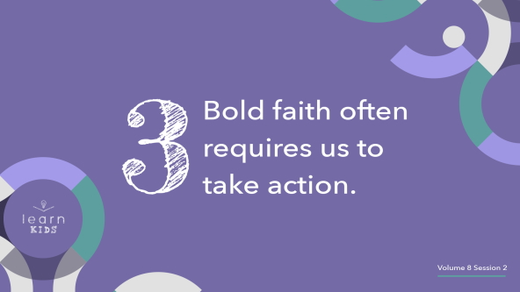

The God we love and serve is a God of action. Sometimes God tells us to do something to show our faith in Him. When we obey, we show how much we trust and need Him. How do you think God feels if He tells us to take a bold step of faith, but we’re too busy or lazy to take action? *(Group response)*

• *Sit down with a bowl of popcorn and a remote. Begin eating popcorn while you continue to talk.*

Imagine God is ready to do something great, but we’re just sitting around. We’re too distracted to do our part. Or we don’t want to take the step of faith He’s telling us to take. In our Bible story, Elisha could have sat down by the river and rested. Elijah even told Elisha he didn’t need to come along, but Elisha wanted to stay with Elijah. God responded to Elisha’s step of obedient faith, and He will respond to ours too.

If Elisha hadn’t taken that bold step to ask for a double share of God’s Spirit and power, he might not have received it. The Bible tells us God did a lot of miracles through Elisha—even more miracles than God did through Elijah. We can’t know how many of those miracles wouldn’t have happened without Elisha’s bold faith.

We don’t want to stand in the way of what God wants to do in our life either. Let’s be ready and willing to do whatever God calls us to do, no matter how it makes us feel. With bold faith, we can live out our Faith Fact. Say it with me: **I believe God can do great things.**

**Prayer and Response**

*Consider playing a worship song softly in the background while kids pray.*

If you’re ready to take a bold step of faith and believe God for something great in your life today, raise your hand.

• *Wait for kids to respond by raising their hands.*

We’re going to literally take a bold step of faith today to show God we believe in Him. If we can’t be bold at church, it’ll be hard for us to be bold around other people. Do you believe God and want Him to do something great in your life? Then get up out of your seat and come to the front.

• *Pause while kids respond.*

We’re going to pray and ask God what great things He has for us. After we talk to God, we’ll spend time listening for Him to answer. Did you know prayer includes both talking to God and listening to Him? The best way to hear God speaking to you is to take plenty of time to listen. Don’t do or think about anything else. Block out the distractions and listen for Him to speak to you. It may not be a loud voice you can hear with your ears. It could be a whisper or a feeling. Let’s take some time to talk to God and listen to Him today.

• *Allow for prayer time.*

• *Then direct kids to sit quietly for a minute or two of silence. Encourage kids to remain respectful during this time.*

**Prayer**

• *Optional: Have the kids repeat phrases of the prayer after you.*

|  |
| --- |
| Dear God, we believe You want to do great things in our life. Help us make time to ask You what those things are and then take time to listen when You answer. Amen. |

**Faith Verse**

Our Faith Verse has an incredible promise in it for those who believe. Let’s do the actions together.

• *Play* ***Faith Verse Video****.*

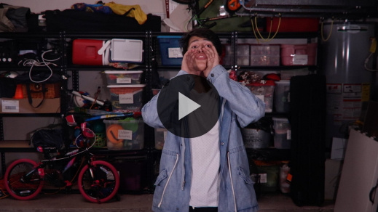

[John 14:12](https://ref.ly/logosref/Bible.Jn14.12) (NLT)

“I tell you the truth, anyone who believes in me will do the same works I have done.”

Think about all the things Jesus did while He was on the earth: He taught people about God, He did amazing miracles, He cared about people and changed their lives. This verse tells us Jesus can use us to do those things too—if we believe in Him.

**Faith Fact**

Before we go to our small groups, let’s say our Faith Fact together one more time.

• *Show the* ***Faith Fact Slide****.*



Say it with me. **I believe God can do great things.** Today we discovered a new way to experience God’s power: believing He can do amazing things. I can’t wait to find out what we’ll learn about His power next time! Let’s go to our small groups.

• *Dismiss kids to Small Group time or to go home if your group time ends here.*

**Small Group**

**30 Minutes**

*This section can be done in conjunction with the large group or on its own if you do small groups with your kids. During Small Group time, the goal is to connect the kids with the Word of God and to each other. All activities are led by the small group leader.*

**Group Connection**

**How Bold Are You?**

|  |
| --- |
| ***You Will Need***   * ***Small Group Group Connection Pag****e, one per group* * *Candy or small prize, one piece per kid* * *Scissors* * *Plastic cups, one per group*   ***Getting Ready***   * *Print copies of the* ***Small Group Group Connection Page****, one per group.* * *Cut each page into slips and place the slips in a cup, one set per group.* |

Do you have bold faith? *(Group response)* Having bold faith means you’re willing to stand out and stand up for what you believe in. It might mean you feel uncomfortable or unpopular sometimes. But bold faith comes from God, and sometimes He directs you to take a bold stand. In those moments, you have to choose whether you’ll have bold faith—and it can be a hard decision to make. So let’s practice being bold.

Each of you will choose a challenge from the cup. If you’re bold enough to take the challenge, I have a prize for you. Let’s answer the question “How bold are you?” and play!

• *Have each kid draw a challenge slip from the cup.*

• *Optional: Propose an alternate challenge if a kid is uncomfortable with the challenge drawn.*

• *Give a small prize or piece of candy to each kid who tries to do the challenge.*

Some of those challenges were hard! They all took a lot of boldness. How did you feel when you chose a challenge and had to decide if you were going to do it? *(Allow responses.)* Being bold isn’t easy. I’m proud of all of you who were willing to take the challenge.

**Learn about It**

|  |
| --- |
| ***You Will Need***   * *Bibles for kids in your group to share* * *Small prize*   *No prep is needed.* |

**Scripture Search:** [**Matthew 21:21–22**](https://ref.ly/logosref/Bible.Mt21.21-22)**;** [**2 Timothy 1:5**](https://ref.ly/logosref/Bible.2Ti1.5)**;** [**Hebrews 11**](https://ref.ly/logosref/Bible.Heb11)

Let’s see what the New Testament has to say about believing God will do great things. As we find and read each of these verses, think about this question: What does this Scripture mean for our life today?

• *Give each kid a Bible and search for one or more of the Scriptures as a group together (as time allows). When everyone has found the Scripture, have one of the kids read it. Then answer the question about it: What does this Scripture mean for our life today?*

• *Pair kids who need additional help with older kids or start simple and look up the session’s Bible story Scripture:* [*2 Kings 2:6–15*](https://ref.ly/logosref/Bible.2Ki2.6-15)*. Kids will get better at finding Scriptures the more they practice.*

• *Optional: Make this a competition to see who can find the Scripture first.*

**Bible Reading Tip**

Having bold faith is easier when you know God’s Word and believe what it says. It’s a good idea to spend time reading both the Old and New Testaments. Maybe you mostly read the New Testament because it’s easier to understand or more interesting. But the Old Testament has many incredible stories about God’s power, including the stories about Elijah and Elisha. Take some time to read books in the Bible you normally don’t spend time in, like [1](https://ref.ly/logosref/Bible.1Ki) and [2 Kings](https://ref.ly/logosref/Bible.2Ki).

**Challenge**

One way to become bolder in your faith is memorizing verses from God’s Word. This can help you share your faith with others. Here are a few Bible verses to get you started: [Romans 3:23–24](https://ref.ly/logosref/Bible.Ro3.23-24); [Romans 5:8](https://ref.ly/logosref/Bible.Ro5.8); [Romans 6:23](https://ref.ly/logosref/Bible.Ro6.23); [Romans 10:9](https://ref.ly/logosref/Bible.Ro10.9).

• *Optional: Help kids look up these verses and mark them in their Bible.*

You don’t need to memorize all these verses this week, but take time to look them up in your Bible and read them. If you read these verses every day, they will get stuck in your head. Then you’ll be ready to share them with someone else when you get the opportunity.

**Faith Fact**

The first person to jump up and say the Faith Fact will get a prize. *(Allow responses.)*

• *Give the first kid a small prize.*

Great job! Now, let’s all jump up and say it together. **I believe God can do great things.**

**Group Discussion**

*Feel free to use all or just a few questions as a jumping-off place for good discussion. Questions marked with * are designed for more conversation. Adjust the questions based on the age or maturity of your group. Typically, older kids will be able to dive a little deeper than younger ones.*

**Questions**

• *If small group activities are not immediately following large group time, you may want to read the Bible story passage before this discussion.*

What did Elisha ask Elijah for?

How was Elijah taken up to heaven?

Are you bold? Or are you quiet and shy?

What is something you believe in but can’t see with your eyes?

* What is something that God did in the Bible that seems impossible?

* What is something that God has done for you or someone you know that seems impossible?

* What does having bold faith mean to you?

How do you think we can grow to have bold faith in God?

* What is one way you can show others that you have bold faith?

Who can you share your faith with this week?

**Prayer Requests**

*Finish group discussion by sharing prayer requests and praise reports. Keep track of your small group’s prayer requests and review them each time you meet.*

**Prayer**

*Have kids pray for each other’s prayer requests.*

**Faith Verse Review**

Our Faith Verse today is [John 14:12](https://ref.ly/logosref/Bible.Jn14.12), where Jesus reminds us how powerful believing in God can be. Let’s say it together before we play a fun and active game.

• *Show* ***Faith Verse Video****.*



[John 14:12](https://ref.ly/logosref/Bible.Jn14.12) (NLT)

“I tell you the truth, anyone who believes in me will do the same works I have done.”

**Faith Verse Fun**

**“Verse-ercise”**

We’re going to say the Faith Verse quite a few times in this activity. We’ll combine the Faith Verse with an exercise to create “Verse-ercise”! So stand up and spread out. Let’s do it!

• *Choose a different exercise to do each time you say the verse: jumping jacks, running in place, squats, toe touches, push-ups, sit-ups, etc.*

• *Keep going for as many rounds as you like. Consider letting kids propose exercises to do too.*

Are you totally worn out yet? *(Group response)* I hope you know our powerful Faith Verse even better after that workout!

**Activity Page**

**A-Mazing Miracles**

|  |
| --- |
| ***You Will Need***   * ***Small Group Activity Page****, one per kid* * ***Small Group Activity Page Answer Page*** * *Pencils, one per kid*   ***Getting Ready***   * *Print copies of the* ***Small Group Activity Page****, one per kid and a* ***Small Group Activity Page Answer Page*** *for you.* |

God used Elijah to do a lot of amazing miracles during his time as a prophet. Then Elisha was bold enough to believe God would allow him to be a powerful prophet too. Draw a path through the maze, passing through all three miracles God did for Elijah and Elisha in today’s Bible story.

• *Give kids time to complete the maze.*

You can read more on your own about Elijah and Elisha’s ministry as prophets of God in [1](https://ref.ly/logosref/Bible.1Ki) and [2 Kings](https://ref.ly/logosref/Bible.2Ki). God did many more amazing miracles through them.

**Dismissal**

This was an incredible day of discovering how powerful our belief in God really is! Remember to keep praying and boldly asking God for great things. Then take time to listen to Him speak to you. Let’s pray to God now as we finish up today.

**Prayer**

|  |
| --- |
| *Dear God, thank You for showing us how important it is to believe in You for greater things. Help us not to be afraid to ask for more, just like Elisha. Amen.* |

**Faith Fact Recap**

• *Show the* ***Faith Fact Slide****.*



Let’s say the Faith Fact together one more time before we go. **I believe God can do great things.** I hope to see you all back next time to learn more about how we can experience God’s power.

• *Send home the* ***Small Group Activity Page.***

• *Remind parents that there are* ***Family Devotions*** *available on the app to do with their kid.*

• *Tell everyone the date and time for the next session.*